Research Report: Cucumber Crops and Common Pests in the United Kingdom
SDG 2 – ZERO HUNGER | PEST 2 VEG PROJECT
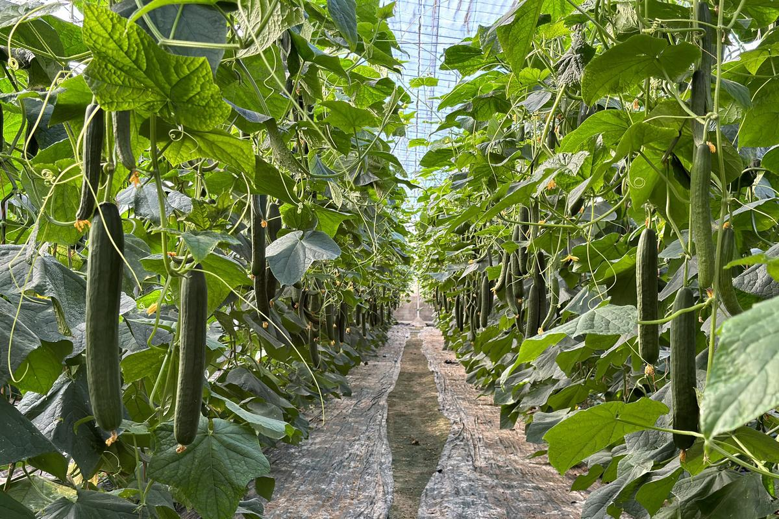
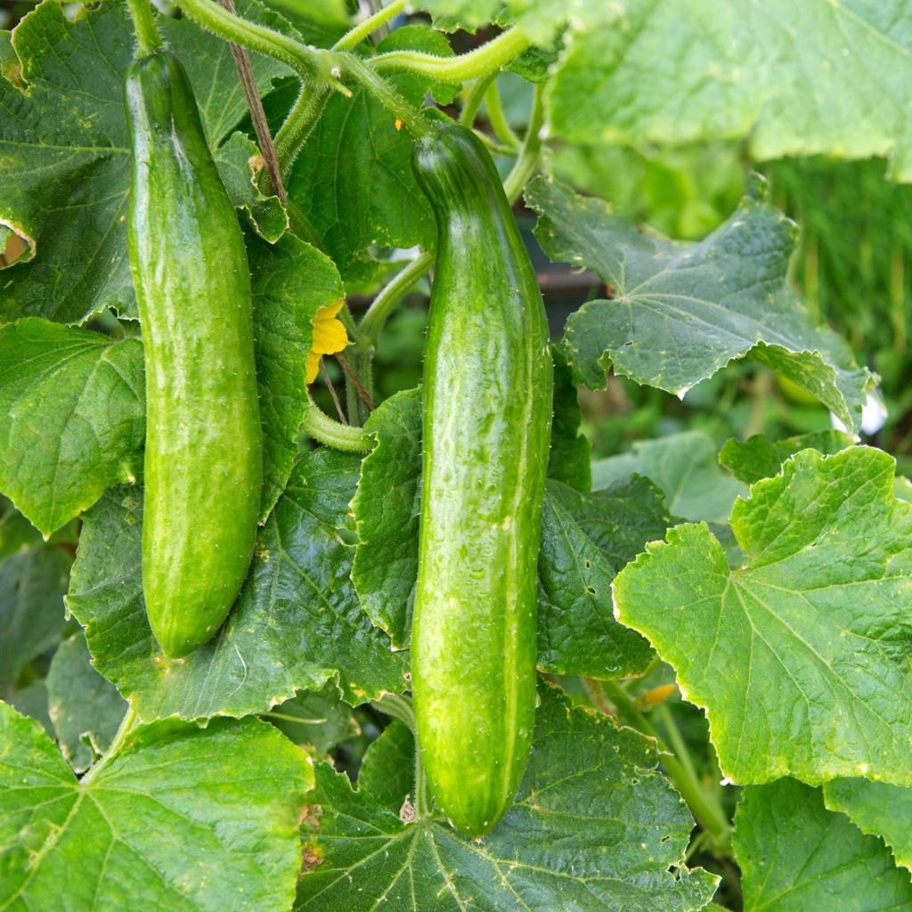
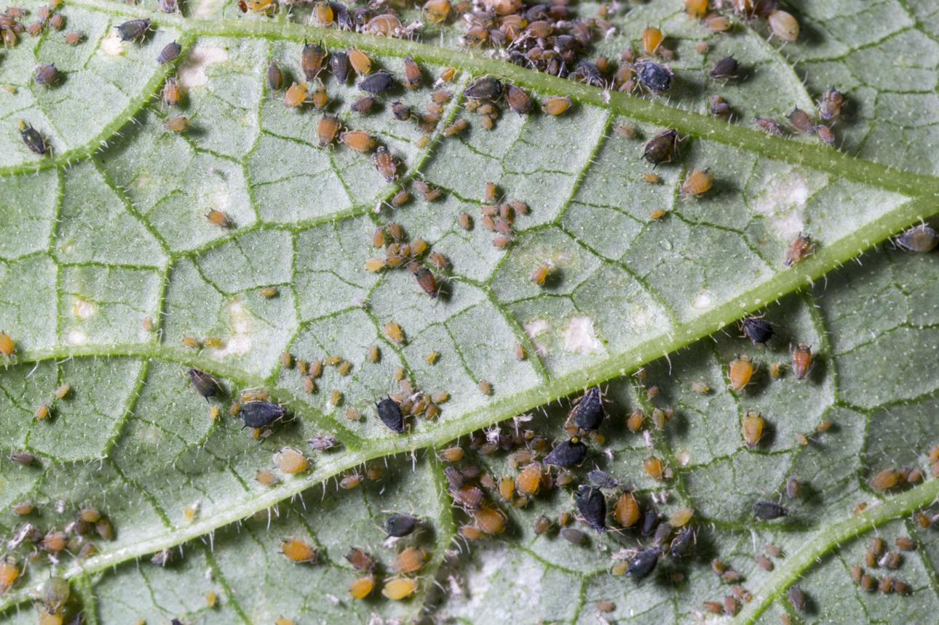
6
1. Introduction
Cucumber (Cucumis sativus) is an important vegetable crop cultivated in the United Kingdom, particularly in commercial greenhouses and domestic gardens. It is widely consumed fresh in salads, sandwiches and other meals.
However, cucumber plants are vulnerable to several insect and mite pests that damage leaves, stems, flowers and fruits. These pests can reduce plant growth, affect crop quality and cause economic losses for growers.
This research supports Pest 2 Veg, a pest information web application aligned with the United Nations Sustainable Development Goal 2 (Zero Hunger). The project aims to help farmers, gardeners and agricultural learners identify cucumber pests, recognise symptoms and understand prevention methods.
Research objectives
- Identify common pests affecting cucumber crops in the UK.
- Explain visible symptoms and crop damage.
- Recommend practical prevention and control methods.
- Identify reliable pest photographs with reusable licences.
- Provide scientifically supported information for the Pest 2 Veg application.
2. Importance of cucumber production in the UK
Cucumbers contribute to UK horticulture by providing fresh produce for consumers and commercial opportunities for greenhouse growers. Protected cultivation allows growers to maintain suitable temperatures and extend the growing season.
Pest management is particularly important because greenhouse conditions can favour rapid reproduction of pests such as aphids, whiteflies and spider mites.
Early pest identification can help growers reduce crop losses and use biological pest controls more effectively.
3. Main pests affecting cucumber crops
The following five pests are relevant to UK cucumber cultivation. Their symptoms may overlap, so identifying the actual organism is important.
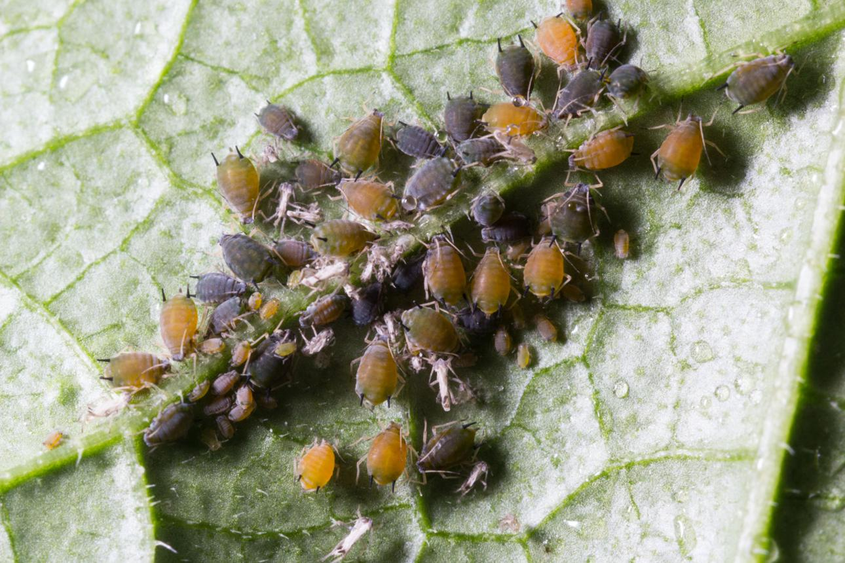
1. Aphids (greenfly)
Aphis gossypii and other aphid species
Small, soft-bodied insects, often green, yellow or dark, which gather on tender shoots and underneath leaves.
Symptoms: Curled leaves, yellowing, stunted growth, sticky honeydew and black sooty mould. Aphids can also transmit cucumber mosaic virus.
Prevention: Inspect leaves regularly, remove small colonies, encourage ladybirds and hoverflies, and use suitable greenhouse biological controls.
RHS Advice
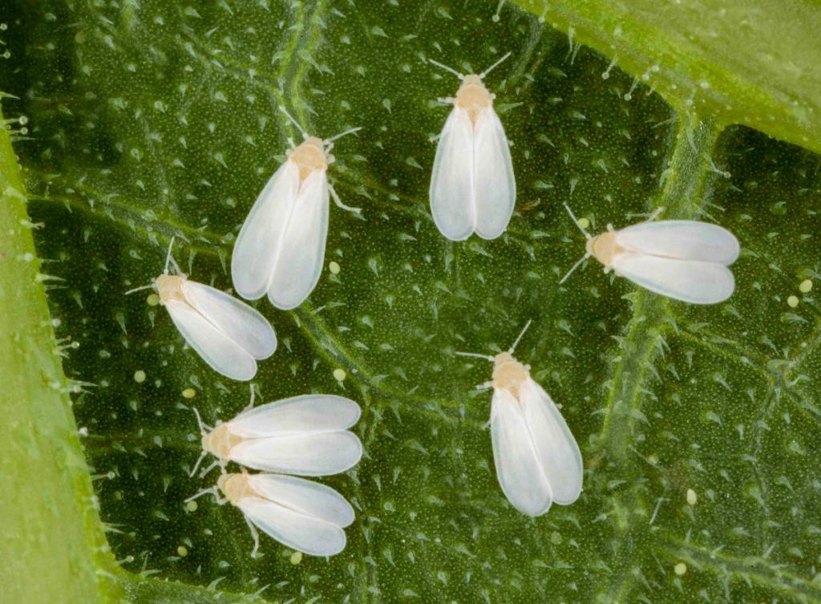
2. Glasshouse whitefly
Trialeurodes vaporariorum
Tiny white-winged insects commonly found on greenhouse plants.
Symptoms: White insects flying up when foliage is disturbed, sticky leaves, black sooty mould and reduced plant vigour.
Prevention: Check new plants, monitor using yellow sticky traps and introduce suitable biological controls, such as Encarsia formosa, where appropriate.
RHS Advice
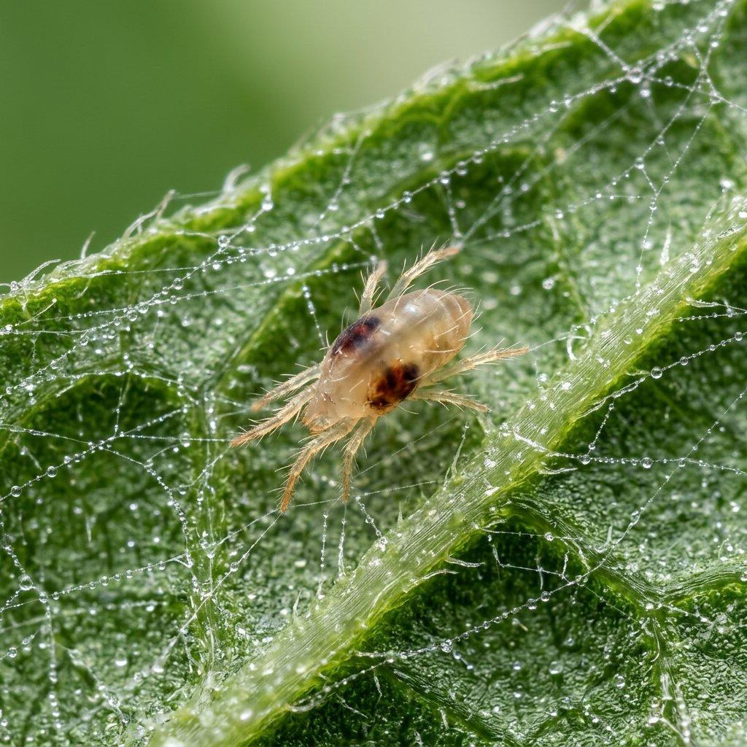
3. Glasshouse red spider mite
Tetranychus urticae
Very small mites which multiply rapidly in warm, dry greenhouse conditions.
Symptoms: Tiny pale speckles, yellow or bronze leaves, fine webbing and premature leaf loss.
Prevention: Inspect leaf undersides, avoid excessively hot and dry conditions, and use appropriate predatory mites for biological control.
RHS Guide
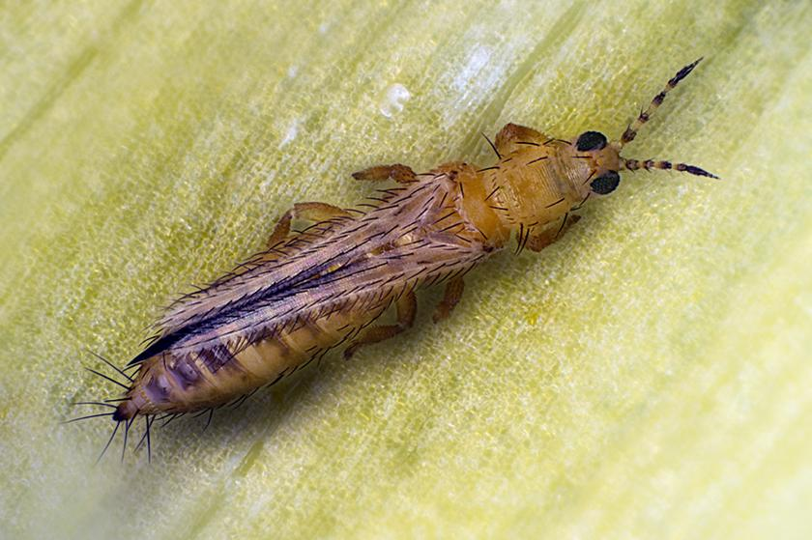
4. Thrips
Including Frankliniella occidentalis
Tiny, narrow-bodied insects that feed on plant tissues.
Symptoms: Silvery or pale patches on leaves, dark feeding spots, damaged flowers and sometimes scarred fruit.
Prevention: Monitor with blue sticky traps in greenhouses, inspect new plants and use appropriate predatory insects or mites.
RHS Advice
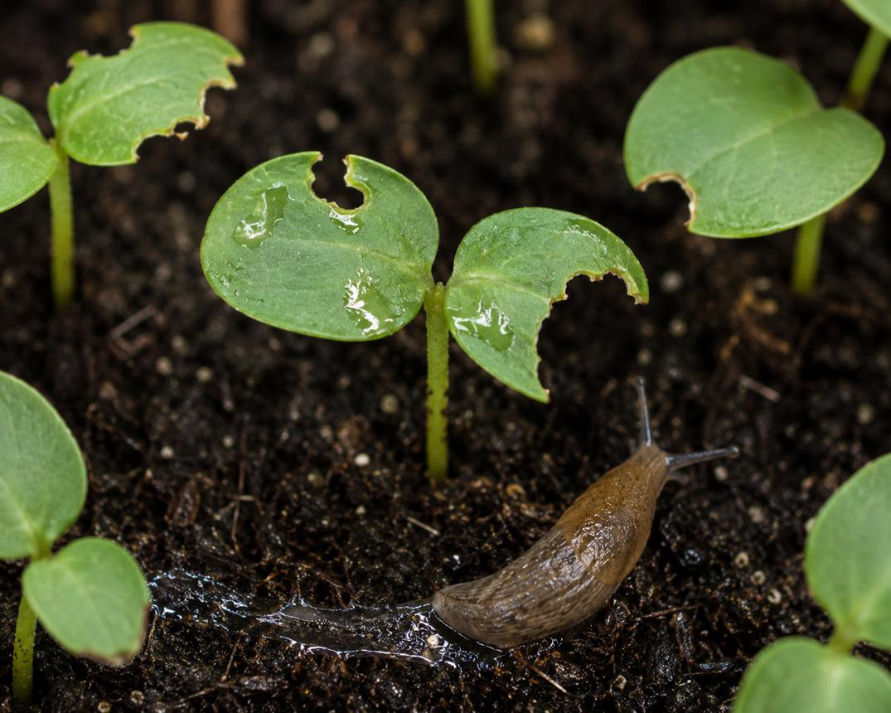
5. Slugs and snails
Various gastropod species
Common outdoor garden pests, especially in damp conditions.
Symptoms: Irregular holes in leaves, damaged young seedlings, feeding marks on low-growing fruits and slime trails.
Prevention: Protect young plants, inspect damp hiding places, remove pests by hand where practical and use suitable physical barriers.
RHS Guide
These are visual identification references, not a verified set of reusable photographs. The licensed image sources are identified separately below.
4. Summary of symptoms and prevention
Pest | Main symptoms | Prevention
Aphids | Curled leaves, honeydew, stunted growth | Regular inspection, natural predators
Whiteflies | White flying insects, sticky leaves | Sticky traps, biological controls
Spider mites | Yellow speckles, webbing | Humidity management, predatory mites
Thrips | Silvery leaves, fruit scarring | Monitoring traps, biological controls
Slugs and snails | Irregular holes, slime trails | Physical protection, hand removal
5. How pest damage can affect food security
Cucumber pest infestations may reduce both crop yield and marketable quality. Serious infestations can increase production costs, cause fruit rejection and reduce growers' income.
Pest 2 Veg can contribute to SDG 2 by making identification and prevention information easier to access. It can also support environmentally responsible crop management through early detection and integrated pest management (IPM).
One particularly important connection is between aphids and cucumber mosaic virus (CMV). Aphids can transmit CMV, which may cause yellow mottling, distorted leaves, reduced growth and malformed fruit. CMV is a plant disease, not itself an insect pest.
RHS Advice
6. Verified reusable pest images and permissions
For your university assignment and Pest 2 Veg website, I recommend using photographs from Wikimedia Commons with clearly stated Creative Commons or public-domain permissions.
I found the following specific files and checked their published licence information.
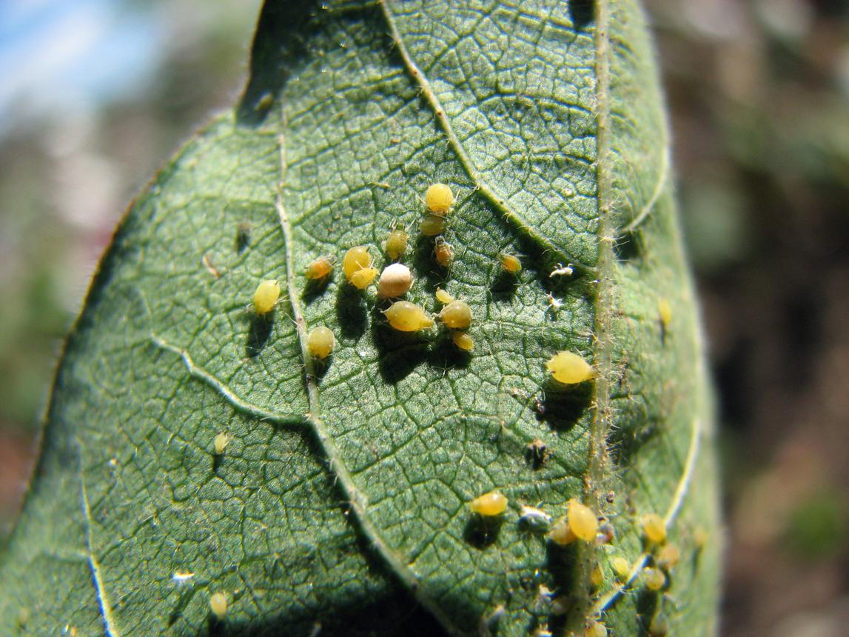
Aphids — Aphis gossypii
CC BY 4.0
Photograph identified as cotton/melon aphid. Reuse and adaptation permitted with attribution.
View licensed photograph and author

Wikimedia Commons
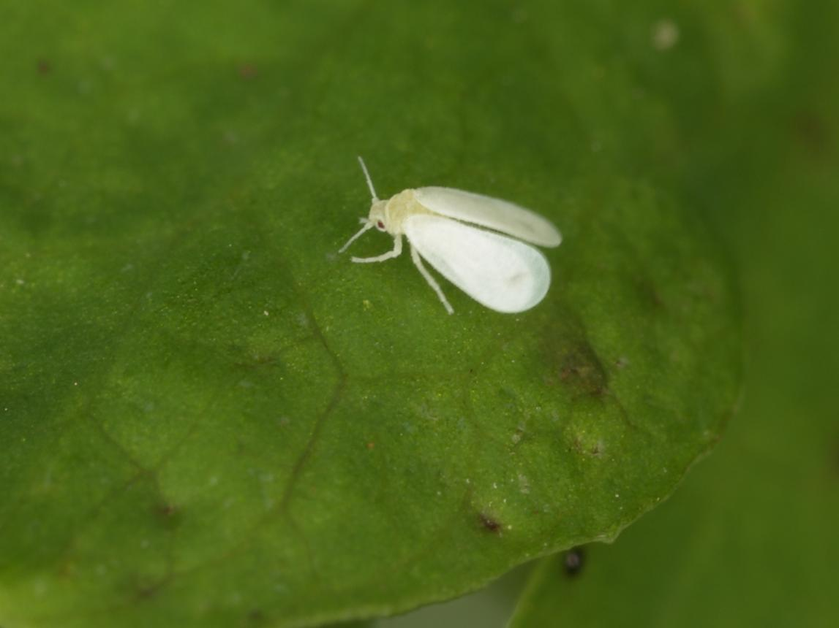
Glasshouse whitefly
Author: Sanja565658
CC BY-SA 3.0. Attribution and applicable ShareAlike requirements apply.
View licensed photograph
Wikimedia Commons
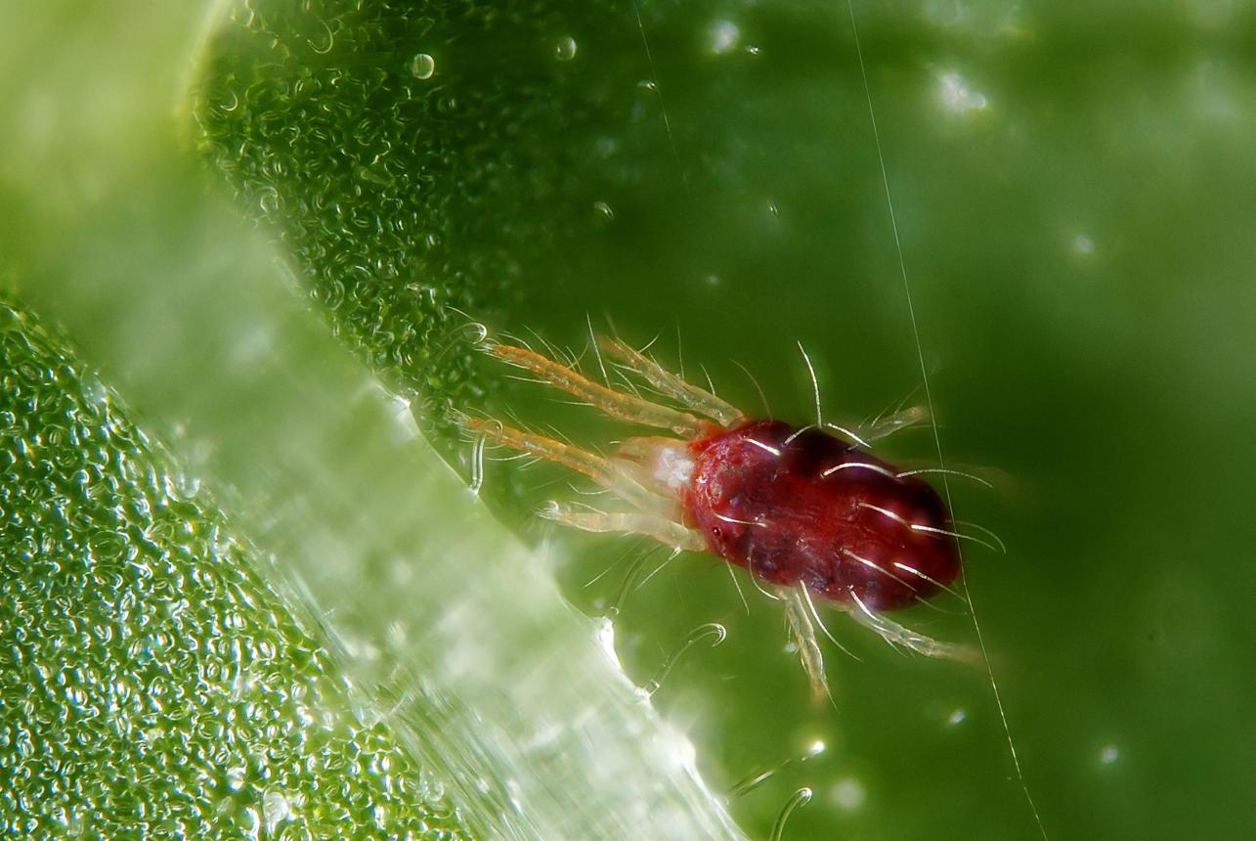
Two-spotted spider mite
Photographer: Gnilenkov Aleksey
CC BY 2.0. Reuse permitted with attribution.
View licensed photograph
Wikimedia Commons
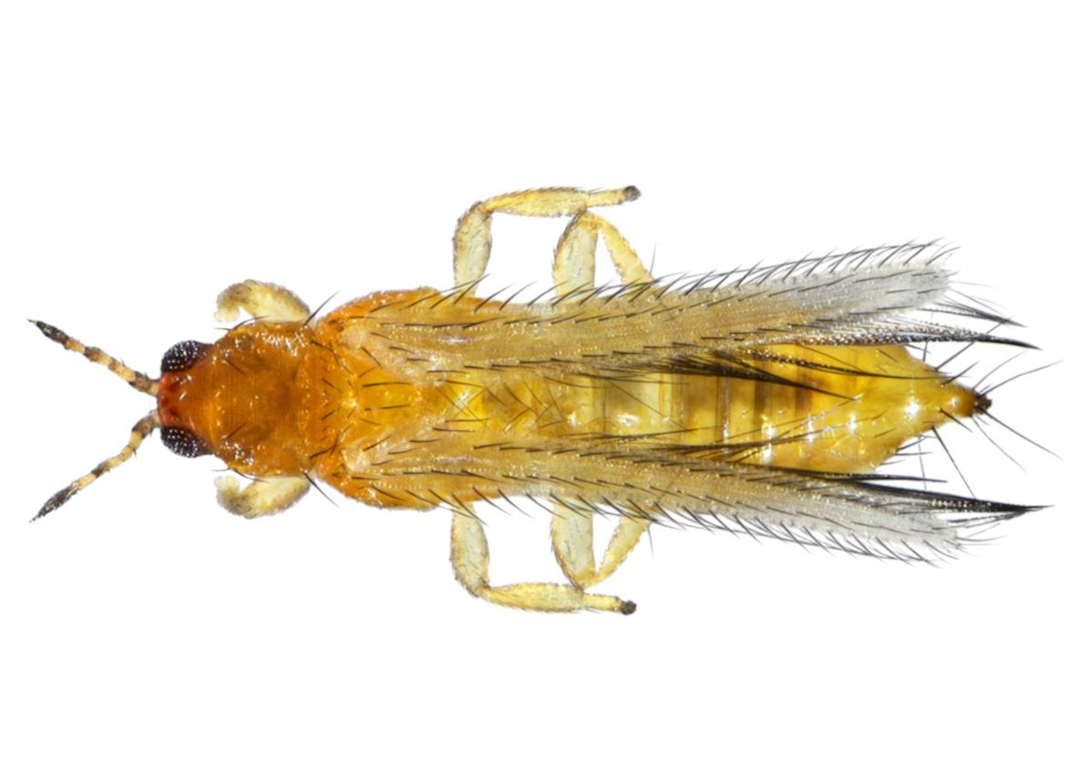
Western flower thrips
Photographer: Jesse Rorabaugh
CC0 1.0. Public-domain dedication; reuse permitted without attribution, although credit is good academic practice.
View public-domain photograph
Wikimedia Commons
Important: The preview images in this answer are illustrative search results. Use the actual photographs from the linked Wikimedia Commons file pages for your assignment, not the previews.
How to verify and use the images
- Open the individual Wikimedia Commons file page.
- Confirm the scientific name in the description and, where available, the original observation or expert identification.
- Find the Licensing section and record the photographer, licence and source URL.
- Download the original image using the file page.
- Include the photographer's name, image title, licence link and any modifications in your report or website.
For example, a suitable credit format is:
Image: Aphis gossypii. Source: Wikimedia Commons. Licensed under CC BY 4.0. Photographer credited as identified on the original file page. View image.
A reusable licence permits use subject to its conditions; it does not prove that the species identification is scientifically correct. For a reliable pest database, keep both the image licence and identification evidence.
7. Suggested Pest 2 Veg application structure
Each pest should have a separate information page with the following fields:
Field | Example for aphids
Crop | Cucumber
Pest | Aphids
Scientific name | Aphis gossypii
Description | Small sap-feeding insects
Symptoms | Leaf curling, honeydew, yellowing
Prevention | Inspection, natural predators
Image | Licensed aphid photograph
Image permission | CC BY 4.0
Research source | Royal Horticultural Society
This structure can be used to develop your Penpot screens, website database and pest identification pages.
8. Research references
The following are useful academic and horticultural references for the project:
- Royal Horticultural Society — How to Grow Cucumbers.
- RHS — Aphids: Symptoms and Management.
- RHS — Glasshouse Whitefly.
- RHS — Thrips.
- RHS — Cucumber Mosaic Virus.
9. Conclusion
Cucumber plants in the UK are affected by several important pests, particularly aphids, whiteflies, spider mites and thrips in greenhouse production, and slugs and snails in outdoor cultivation.
Recognising symptoms early, encouraging natural predators and adopting integrated pest management can help protect cucumber crops.

